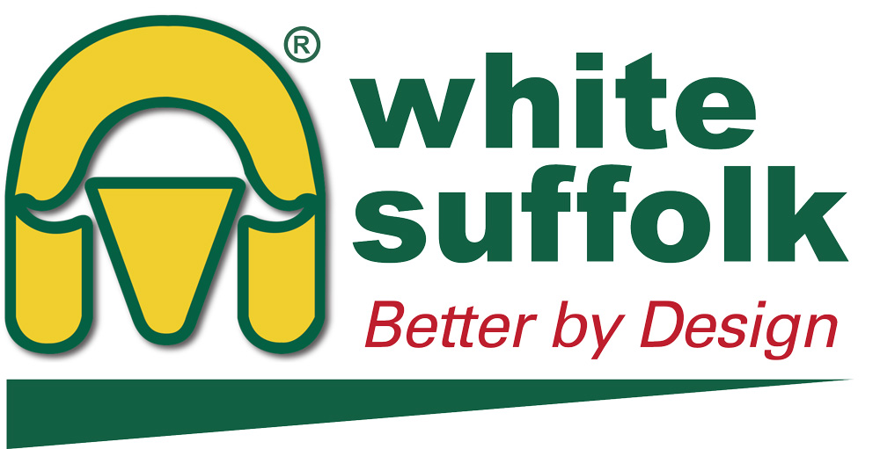
AUSTRALIAN WHITE SUFFOLK ASSOCIATION INC

PROMOTIONAL CLOTHING ORDER FORM

Name: Stud Prefix: Flock No:
Address:

CLOTHING ORDER

Item |  | Cost per item  (inc GST) |  | Quantity | Size | Colour | Stud Name @ $5.00  per item (GST incl) | Total
AWSA Microfibre Vest  Show Uniform (NV5300) |  | $50.00 |  |  |  | Black only | N/A
SHIRTS
Mens Chambray Shirt  Long (SH112) or Short Sleeve (SH113) |  | $49.00 l/s  $48.00 s/s |  |  |  | Blue only
Ladies Chambray Shirt  Long (LB6201) or Short Sleeve (LB6200) |  | $49.00 l/s  $48.00 s/s |  |  |  | Blue only
POLO SHIRTS
Crew Polo Shirt  Mens (P400MS) or Ladies (PM400LS) |  | $30.00
Kids Crew Polo Shirt  (P400KS) |  | $28.00
RUGBY TOPS
Traditional Rugby Top  Mens (3R) or Ladies (3LR) |  | $50.00
Denim Collar Rugby Top  Mens only (3RDC) |  | $50.00
CAPS
Cap with Contrast Piping in Peak  (4210) |  | $18.00 |  |  | N/A
Cap with Suede Peak  (4200) |  | $18.00 |  |  | N/A

DELIVERY: All clothing orders will be posted to you unless otherwise arranged
Postage costs will be invoiced to you – cost will vary between $10-$30 depending on destination and weight of items

A Tax Invoice/Receipt will be forwarded to you with your clothing order.
Payment can be made via CHEQUE or DIRECT DEPOSIT (bank details below).
Account Name: Australian White Suffolk Association, BSB: 085-005, Account No.: 64693 0119
Please advise of all electronic payments by email whitesuffolk@gmail.com or fax (08) 8231 4173

AWSA Microfibre Vest  Show Uniform (NV5300)  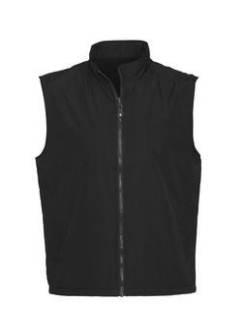  Style: (NV5300)  Sizes Available: (chest size in cm)  XS (107cm) XL (127cm)  S (112cm) XXL (132cm)  M (117cm) 3XL (137cm)  L (122cm) 5XL (148cm) | Chambray Shirt  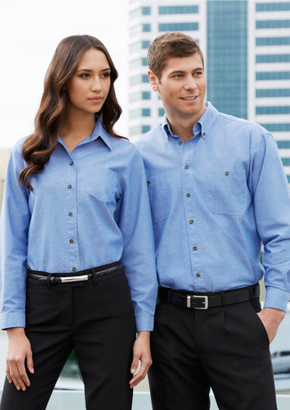  Mens: Long Sleeve (SH112)  Short Sleeve (SH113)  Ladies: Long Sleeve (LB6201)  Short Sleeve (LB6200)  - 100% Cotton with Wrinkle Free Treatment  - Mens style features button down collar and 2 chest pockets  - Traditional fit with centre back box pleat  - Ladies style is a relaxed fit with straight hemline and side splits and 1 chest pocket  - UPF Rating – very good | Polo Shirts  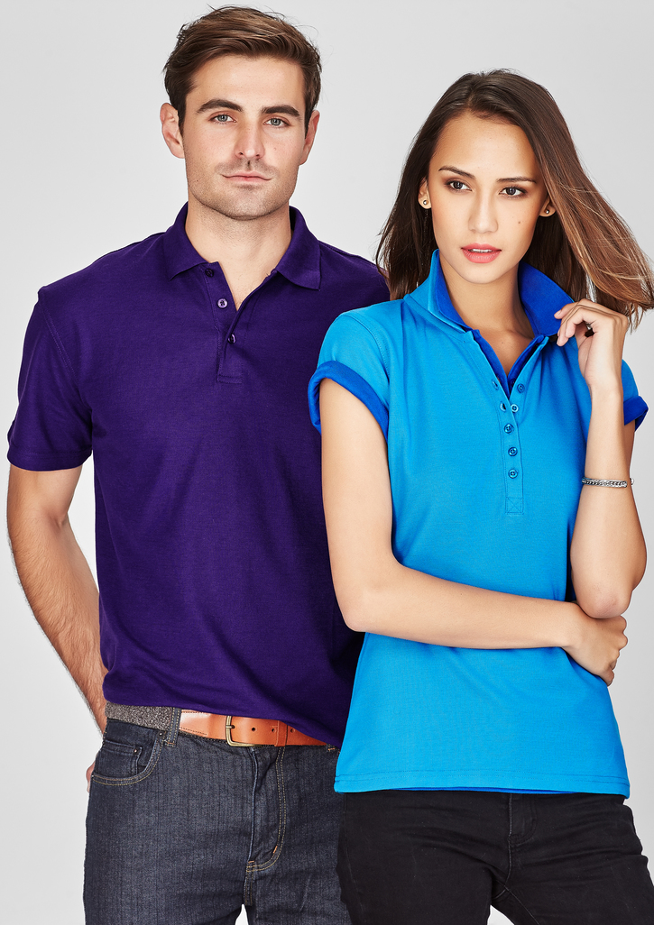  Unisex: P400MS  Childrens: P400KS  - Durable top-stitched armhole and twin needle sleeve/hem  - Knitted flat collar for sleek appearance  - UPF Rating – very good  Colours – grey, charcoal, black, fuchsia, maroon, red, orange, gold, royal blue, navy, cyan, light blue, teal, Kelly green, forest green, white, purple | Traditional Rugby Top  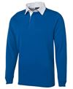  Unisex: Sizes: S to 5 XL  Colours – black/white, maroon/white, navy/denim, red/white, royal/white, bottle/white, navy/white  - 65% Polyester for durability, and 35% Cotton for comfort.  - Ribbed sleeve cuffs and an internal contrast woven back neck dome.  - 350gsm rugby knit fabric, Straight hem with side splits.  - JB's concealed 3-button placket  - Classic Fit

Cap with Suede Peak  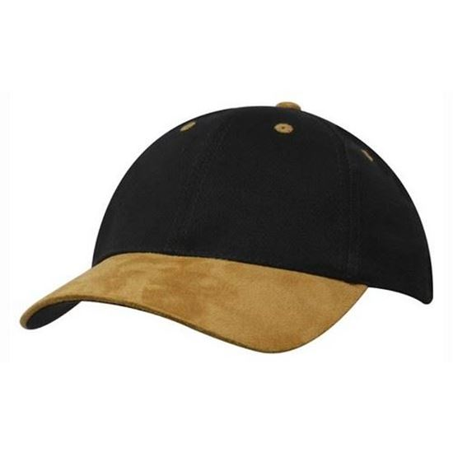  Style: 4200  Sizes: One size fits all  Structured 6 panel with low profile pre-curved peak. Brushed cotton under, fabric covered and short touch strap.  Colours available (cap/peak):  Black, Black/Bottle, Black/Grey, Black/Red, Black/Tan, Bottle/Tan, Maroon/Tan, Navy, Navy/Bottle, Navy/Grey, Navy/Red Navy/Tan, Natural/Bottle, Natural/Navy, Natural/Red, Natural/Tan, Royal/Tan | Cap with Contrast Piping in Peak  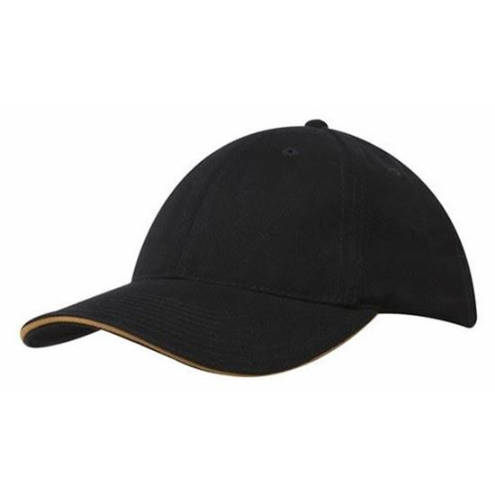  Style: 4210  Sizes: One size fits all  Brushed heavy cotton with sandwich trim.  Structured 6 panel, low profile pre-curved peak.  Brushed cotton under, fabric strap and buckle.  Colours available:  Black/Gold, Black/Orange, Black/Red, Black/White, Bottle/Gold, Bottle/White, Gold/Black, Gold/Bottle, Grey/Black, Maroon/Gold, Navy/Gold, Navy/Red, Navy/White, Red/Black, Red/White, Royal/Gold, Royal/White, Stone/Navy, White/Navy | SIZE CHARTS  Please note: all measurements are approximate and for guidance only  All measurements in centimetres  